Lesson Plan Overview (1 hr lesson plan):
Overall goals:
- Understand the definition of “inspiration porn”
- Understand how disabled folx are often used as inspiration porn for able-bodied folx
  - Answer question: How do disabled people become inspiration porn?
- By the end of the lesson: be able to apply learned knowledge to give their own example of what inspiration porn that uses disabled people
Audience: Bay Area high school students (ages 14-18)

Materials Prepared Beforehand:
- Inspiration Porn examples (with alt text and image descriptions)
- Transcript of Stella Young’s video (reminder for closed captioning)

Part 1: Writing and Discussion
00:00 - 10:00: Watch Stella Young’s “I’m not your inspiration, thank you very much”
10:00 - 13:00: 1-2 minute free-writing activity
13:00 - 15:00: 2 minute discussion of with 1 partner on free-write
15:00 - 30:00: 10-15 minute discussion
30:00 - 35:00: 5 minute break
Part 2: Slideshow Presentation
35:00 - 45:00: Slideshow presentation
Part 3: Application of Concepts
45:00 - 60:00: Inspiration Porn material analysis group activity

Part 1: Writing and Discussion
One minute writing activity:
- Goal:
  - have students understand what the process of ‘objectification’ is
  - Introduce the idea of dehumanization
Have students write for one minute answering the following question:
- “What does Stella mean when she says that disabled people are turned into objects?”

Two Minute Discussion:
Discussion Prompts:
- Can you summarize what you wrote for your partner?
- What was the first sentence you started your free-write with?
- What was the last sentence you wrote for your free-write?

Ten to Fifteen Minute Discussion:
- Goal: get students comfortable with sharing information with each other for the purposes of collective learning
Ask students to volunteer what they discussed with their partner (it will be awkward, but you have to wait a long long time until someone answers)

How can compliments like “you’re so brave” or “you’re such an inspiration” be objectifying?
- Stop and discuss activity: Can you think of a time when someone complimented you in an objectifying manner? How did that make you feel?

Part 2: Slideshow Presentation
Slideshow Presentation Material - Topic: Inspiration Porn
Prior knowledge that students are ideally familiar with:
- What is able-bodiedness and ableism?
- What is disability?
- What does it mean to objectify something or someone?

One of the most common and few ways that able-bodied folks interface with disabled folks in an able-bodied society/culture is turning disabled people into “inspiration porn.”

What is inspiration porn?

Assumption that disability is Bad, and that to live with a disability is an exception

Why the word porn?
- Because it’s an objectification of one group of people for the benefit of another group of people—in this case, it’s the objectification of disabled folx for the benefit of non-disabled folx
- The benefit being that able-bodied folx use the objectification of disabled people to motivate, or to inspire, to remind able-bodied people that “at least they aren’t disabled.”

Social model of disability: we are more disabled by society that we live in with our disabled selves, rather than by our bodies and our diagnoses
WHAT TO UNLEARN: disability is bad, and disability makes you exceptional
Learn from other disabled folks strengths and endurance, not against our bodies and diagnoses, but against a society that exceptionalizes and objectifies 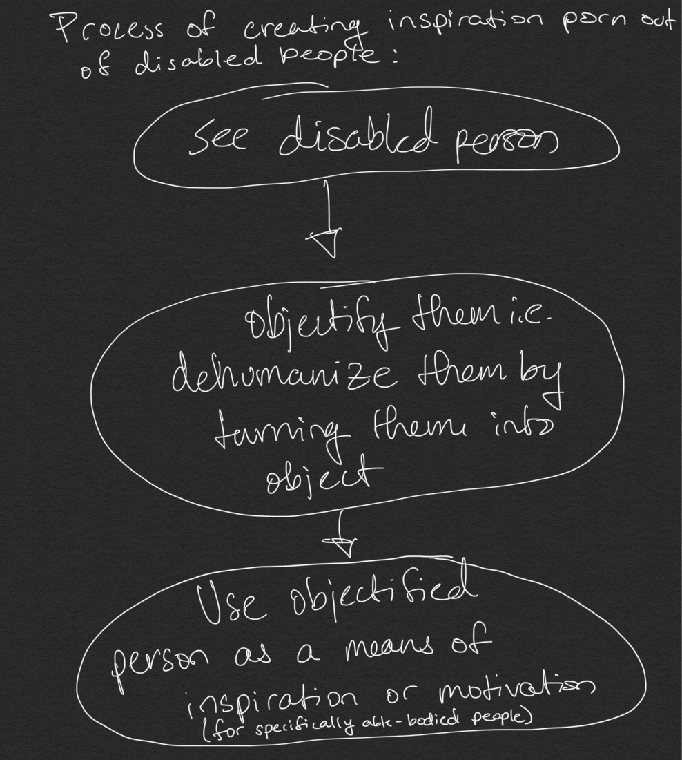
image description: The process of creating inspiration porn out of disabled people. Step 1: see disabled person. Step 2: Objectify them i.e. dehumanize them by turning them into object. Step 3: Use objectified person as a means of inspiration or motivation (for specifically able-bodied people).
Part 3: Application
Written, Visual and Audio Inspiration Porn Analysis Group Activity:
- Prepare a selection of inspiration porn in a variety of different forms (written, visual and audio)
- Divide students into assigned groups and ask them to analyze and discuss examples of inspiration porn
- Optional: groups can share what they talked about or post onto shared platform

